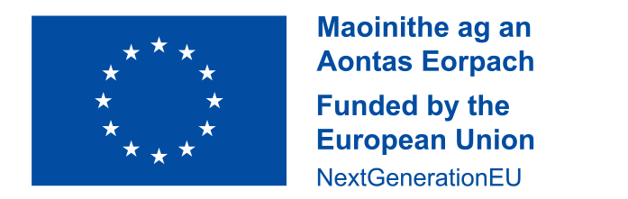

Thanks to funding provided under Circular 60/2021, our school has been able to take a significant step toward closing the digital divide for our students.  
  
This school received a grant in 2021 to implement initiatives aimed at addressing the digital divide and support our learners at risk of educational disadvantage as a consequence, as part of the Irish National Recovery and Resilience Plan (NRRP) a project under the Recovery and Resilience Facility funded by the European Union through NextGenerationEU.

This funding was used to purchase smartboards for each classroom and to upgrade our existing iPads and Chromebooks. Headphones were also purchased for student use. Students who may not have access to digital devices at home are becoming digitally literate on multiple devices, ensuring they can fully participate in learning both inside and outside the classroom.

This investment is already having a positive impact. Students are accessing learning content in multiple ways. They are becoming competent at typing and using spell check tools and some are using speech-to-text options. All children are achieving the same learning outcomes by having the autonomy to choose how they access and demonstrate their learning. They are making progress on educational apps that support their literacy and numeracy skills and they are excited about learning.

Having access to these devices in school and learning how to be responsible and safe online is something that students at risk of educational disadvantage may not otherwise experience. It has enabled and enriched all of our pupils’ learning experiences.